Organized

Industrial Visit

09/05/2023 (Tuesday)

At

Indian Space Research Organization, Department of Space
[Vikram Sarabhai Space Exhibition (VSSE)]
[Space Application Centre]

Dist.: Ahmedabad

Coordinator Faculties Visited
Prof. D.S. Jani Prof. Baraiya Dhaval

CONTENT
- Acknowledgement 3
- General Information 4
- Purpose of visit 5
- What we learnt? 6
- Visit snaps 7
- Conclusion 8

ACKNOWLEDGEMENT

We are thankful to our honorable Principal, Dr. H. M. Nimbark and Head of the Department Prof. V.T. Patel and Admistrative Head Kamleshbhai Patel and our faculties who have given us a great guidance regarding industrial visit.

We are thankful to Vikram Sarabhai Space Exhibition (VSSE) Space Application Centre ISRO - Ahmadabad, for sharing the information about ISRO...

GENERAL INFORMATION

Indian Space Research Organisation (ISRO) is the space agency of India. The organisation is involved in science, engineering and technology to the benefits of outer space for India and the mankind. ISRO is a major constituent of the Department of Space (DOS), Government of India. The department executes the Indian Space Programmeprimarily through various Centres or units within ISRO.

ISRO was previously the Indian National Committee for Space Research (INCOSPAR), set up by the Government of India in 1962, as envisioned by Dr. Vikram A Sarabhai. ISRO was formed on August 15, 1969 and superseded INCOSPAR with an expanded role to harness space technology. DOS was set up and ISRO was brought under DOS in 1972.

PURPOSE OF VISIT

Our main purpose of this visit is to familiarize the students of 2nd semester with industrial environment and to get practical knowledge of engineering field. Also the main aim of this visit is to study the various types of mechanical instrument.

What we learnt?

- 3D TV without spectacles
- Augmented Reality
- Virtual Presenter
- GSLV Animation
- Kids Section
- Interactive BHUVAN

Flight suit

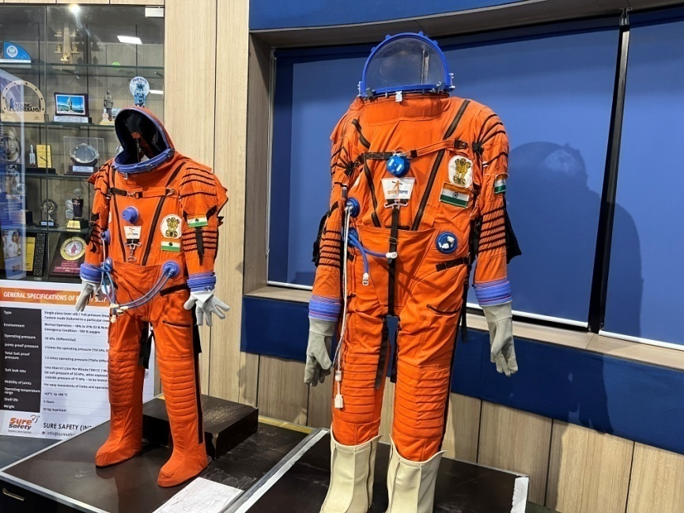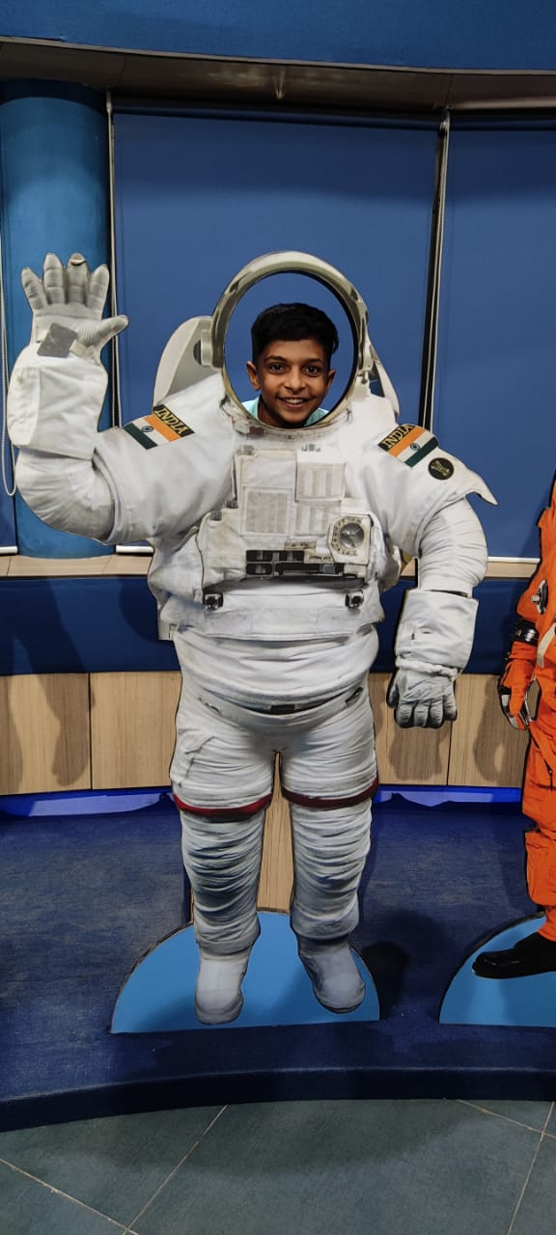

Visit snaps

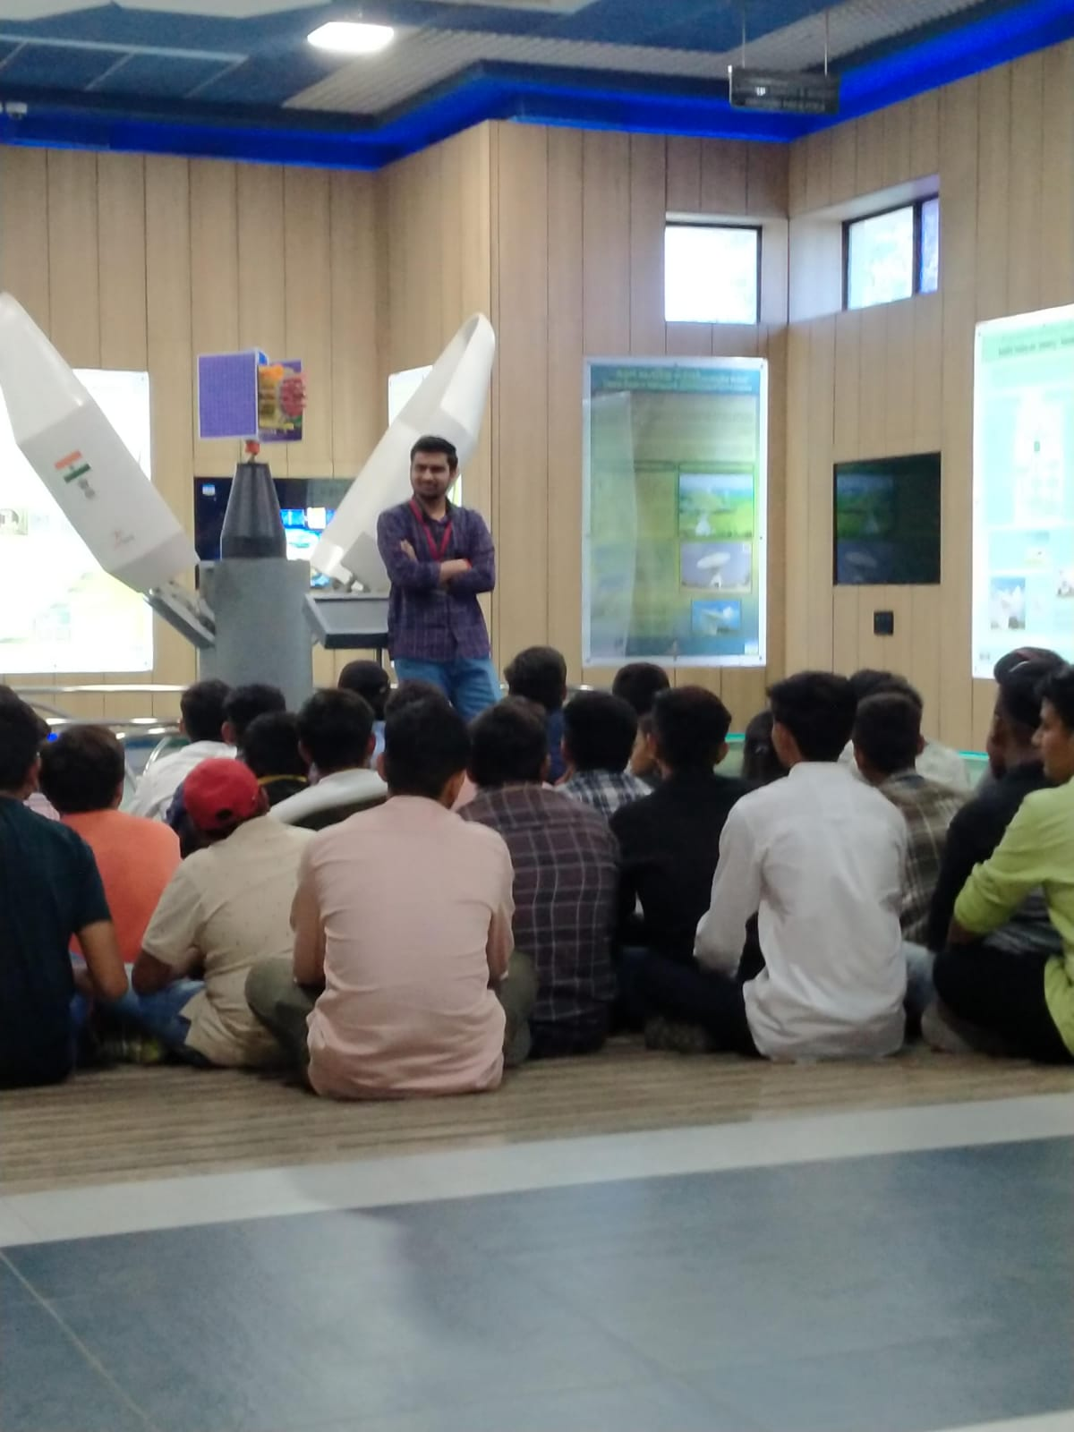

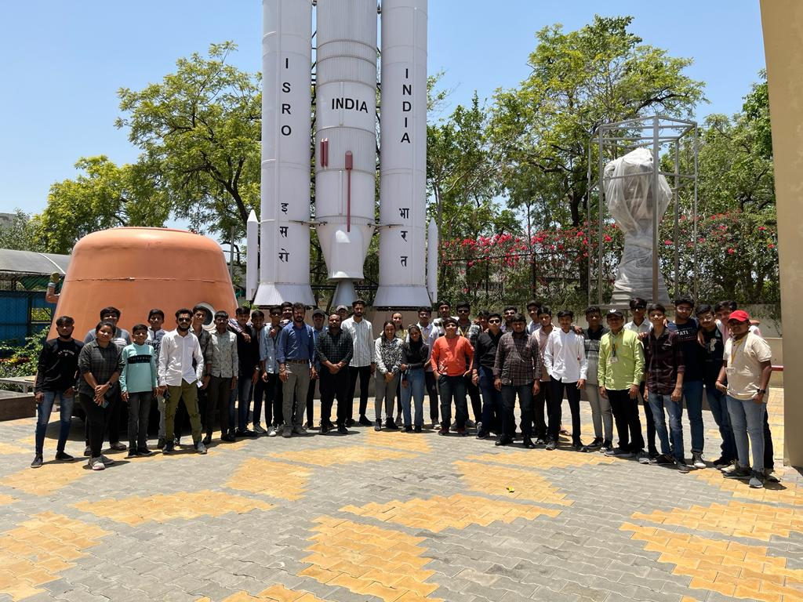

CONCLUSION

From this visit, we got the information and practical knowledge about 3D TV without spectacles, Augmented Reality and About Space technology.
The numbers of persons are 41, Where in Civil 14 students, In Mechanical 13 students and in Electrical 10 Students & 4 staff members & faculty named Prof. Dhaval Baraiya from Mechanical Department benefited from this visit as
They got chance to discussion with Senior Scientist and other engineers working at
ISRO in Vikram Sarabhai Space Exhibition (VSSE) Space Application Centre ISRO - Ahmadabad. Students were eagerly to say organizing this type of
Industrial visit for practical exposure which is shows the success of this visit.

