

Gyanmanjari Institute of Technology
&
Gyanmanjari Diploma College
Bhavnagar

SDP

Date: 21/03/2026
No. of Student | 18
Department | Chemical Engineering
Semester | ALL
Faculty Co-ordinator | Dr. Koushik Ghosh

Startup Opportunities Report

Introduction
Chemical Engineering is one of the most versatile branches of engineering that combines chemistry, physics, mathematics, biology, and economics to develop processes for manufacturing valuable products. In the present era of innovation and entrepreneurship, chemical engineers have excellent opportunities to establish startups in various industrial and sustainable sectors.
Objective of Report
The objective of this report is to highlight startup opportunities available for students and graduates of Chemical Engineering and to motivate young engineers toward entrepreneurship.
Major Startup Opportunities in Chemical Engineering
1. Water Treatment and Wastewater Management
Startups can develop innovative technologies for industrial wastewater treatment, water purification systems, RO plants, and recycling solutions.
2. Renewable Energy and Biofuels
Chemical engineers can establish ventures in biodiesel, ethanol production, hydrogen energy, solar thermal systems, and waste-to-energy technologies.
3. Specialty Chemicals Manufacturing
There is strong demand for adhesives, paints, coatings, detergents, cleaning chemicals, cosmetics, and performance chemicals.
4. Food and Beverage Processing
Startups can focus on food preservation, dairy processing, packaging materials, beverages, and nutraceutical products.
5. Pharmaceutical and Biotechnology Industries
Chemical engineers can work in drug formulation units, fermentation industries, vaccine production, and healthcare product manufacturing.
6. Environmental Solutions
Businesses related to air pollution control, solid waste management, plastic recycling, and green chemistry are highly promising.
7. Process Automation and Consultancy
Chemical engineers can offer plant design, safety audits, simulation services, energy audits, and industrial consultancy.
Benefits for Students
- Self-employment opportunities
- Job creation potential
- Innovation and research commercialization
- Contribution to sustainable development
- High growth industrial sectors
Role of Gyanmanjari Innovative University
The university encourages entrepreneurship through technical education, industrial exposure, innovation projects, startup mentoring, skill development programs, and incubation support for students.
Conclusion
Chemical Engineering offers enormous startup potential in modern industries. Students of Gyanmanjari Innovative University can use their technical knowledge, creativity, and problem-solving skills to become successful entrepreneurs and contribute to industrial and national development.
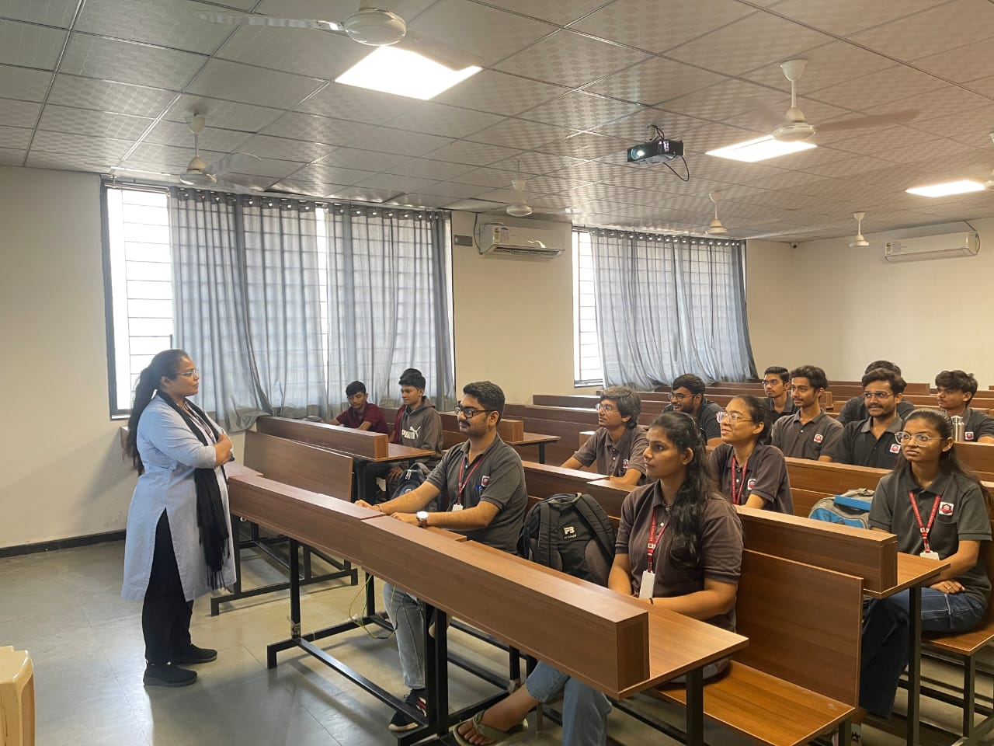
______________________XXXXXXXXXXXXXXXXXXXXXX_____________________

